**Task on Jenkins**

1) Install jenkins and run jenkins on port number 8081  
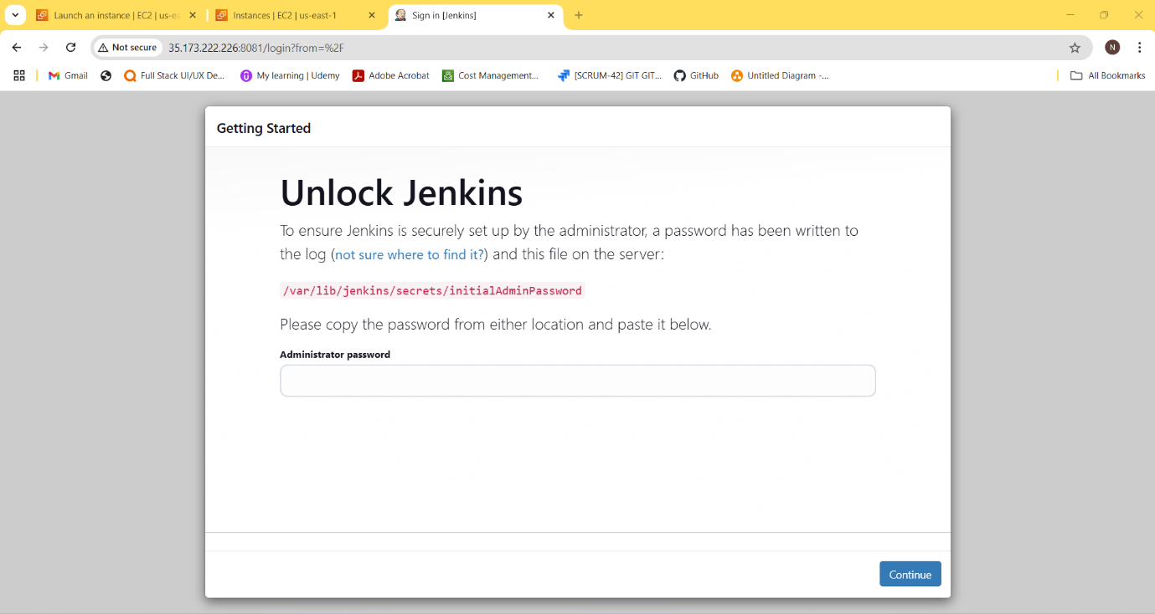

2) Secure Jenkins server

3) Create users called Devops, Testing in Jenkins with Limited access

5) Create Three sample jobs using the below URL

6) Create one jenkins job using git hub Private repository  
